|  |
| --- |
| Information *forensics 10pts* |
| Description:  Files can always be changed in a secret way. Can you find the flag? cat.jpg |

1. Download the jpeg image and *cd* into its directory.
2. Use exiftool to uncover metadata by typing in the command: *exiftool cat.jpg*
   1. To install the tool, use the command: *sudo apt install libimage-exiftool-perl*
   2. NOTE: this is different than the *exif* command, which is for another tool and won’t generate the needed metadata.
3. The license looks like it’s encoded with base64.
   1. https://en.wikipedia.org/wiki/Base64
4. Echo the license string into the *base64 –d* command to decode by typing the following terminal command: *echo cGljb0NURnt0aGVfbTN0YWRhdGFfMXNfbW9kaWZpZWR9 | base64 –d*
5. The flag will be decoded.

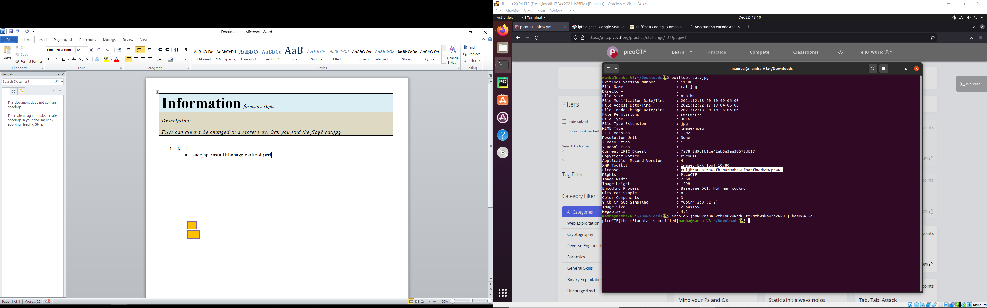

4

3

2